**TASK 1**

# CREATE A SIMPLE FREESTYLE JOB TO INSTALL NGINX ON YOUR SERVER

**(TOOLS: JENKINS AND UBUNTU VM)**

**Step 1:** Create a new freestyle project named “task1”

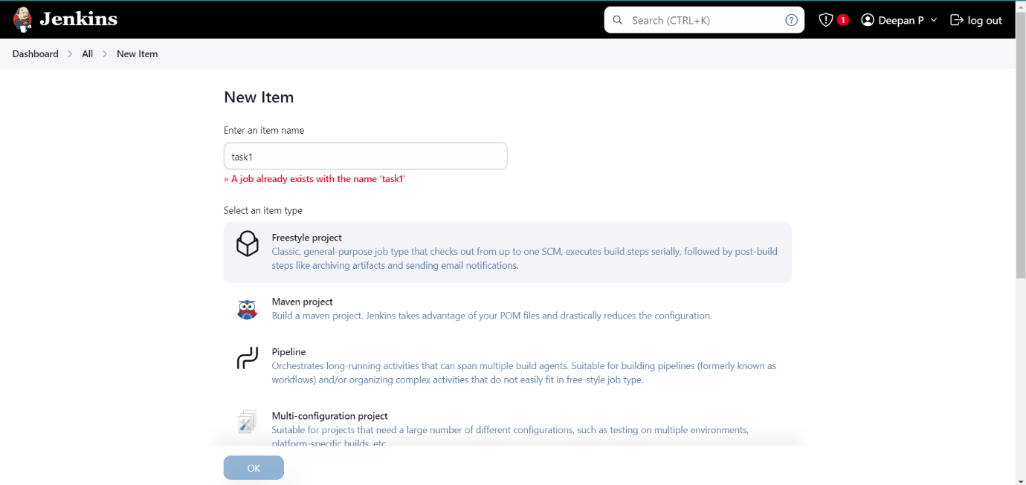

**Step 2:** Create a directory “/var/lib/jenkins/workspace/html_files” and create index.html file

in it

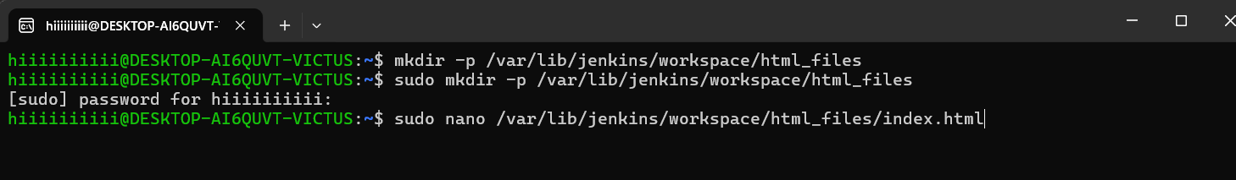

# In index.html

<!DOCTYPE html>

<html lang="en">

<head>

<meta charset="UTF-8">

<meta name="viewport" content="width=device-width, initial-scale=1.0">

<title>Welcome to My Website</title>

<style>

body { font-family: Arial, sans-serif; background-color: #f4f4f4; margin: 0; padding: 0; text-align: center;

}

.container { width: 50%; margin: 100px auto; background: white; padding: 20px; border-radius: 10px; box-shadow: 0px 0px 15px rgba(0, 0, 0, 0.2);

} h1 { color: #007bff;

} p { font-size: 18px; color: #555;

}

</style>

</head>

<body>

<div class="container">

<h1>Welcome to My Nginx Website!</h1>

<p>This page is hosted using Nginx installed via Jenkins.</p>

</div>

</body>

</html>

**Step 3:** Open the execute shell and enter the following command

# Update and install Nginx sudo apt update sudo apt install -y nginx

# Start and enable Nginx service sudo systemctl start nginx sudo systemctl enable nginx

# Copy the manually created HTML file to Nginx root sudo cp /var/lib/jenkins/workspace/html_files/index.html /var/www/html/

# Restart Nginx to apply changes sudo systemctl restart nginx

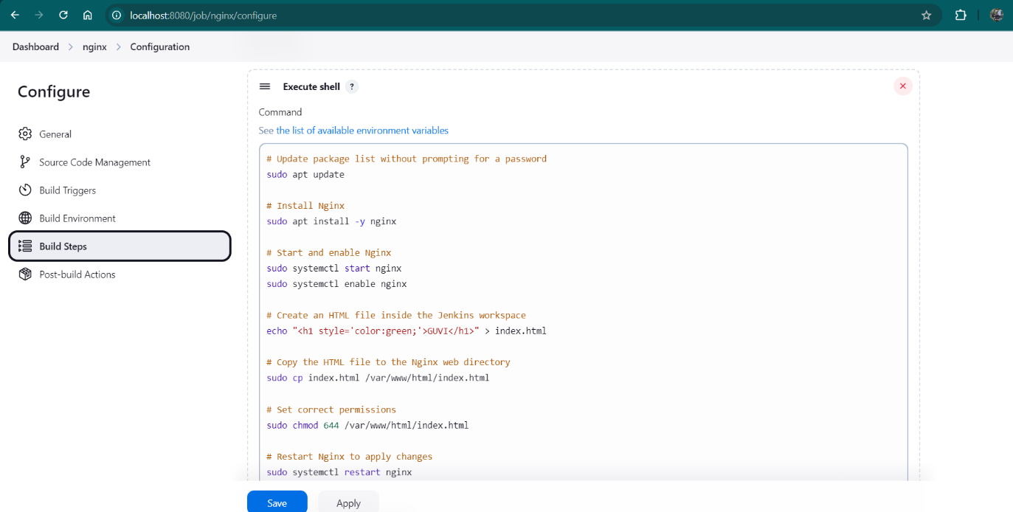

**Step 4:** Run the Jenkins Job by clicking on Build Now

**Step 5:** Check the Console Output to verify

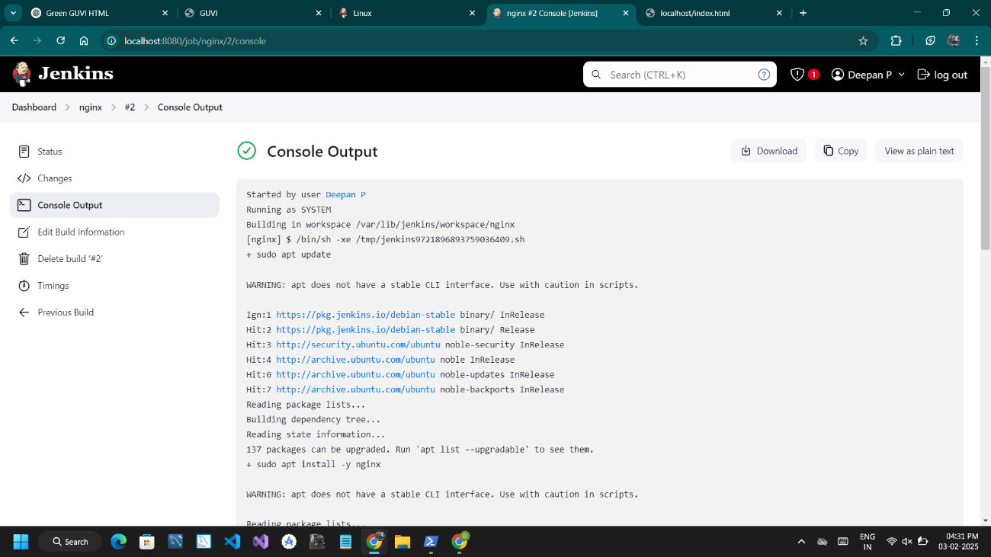

**Step 6:** Go to [http://localhost](http://localhost/) and verify the output

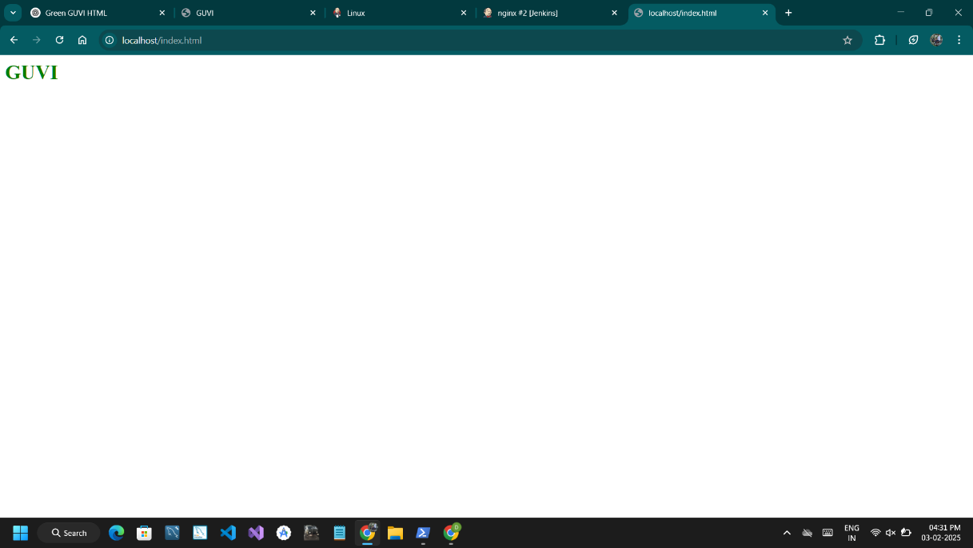

**Step 7:** Check whether the changes to the index.html reflects to the output

# In index.html



